Title of Your Mini Lab Project

Submitted By

Student Name | Student ID
Student-1 Huzayfa Talha | Student-1 ID:222-15-6106

MINI LAB PROJECT REPORT
This Report Presented in Partial Fulfillment of the course CSE114: Programming and Problem Solving Laboratory in the Computer Science and Engineering Department



DAFFODIL INTERNATIONAL UNIVERSITY
Dhaka, Bangladesh
December 11, 2025

DECLARATION
We hereby declare that this lab project has been done by us under the supervision of Md. Ashraful Islam Talukder, Lecturer, Department of Computer Science and Engineering, Daffodil International University. We also declare that neither this project nor any part of this project has been submitted elsewhere as lab projects.

Submitted To:

Md. Ashraful Islam Talukder
Lecturer
Department of Computer Science and Engineering
Daffodil International University

Submitted by

Huzayfa Talha
HU

Student Name:
ID:222-15-6106
Dept. of CSE, DIU

COURSE & PROGRAM OUTCOME

The following course has course outcomes as following:

Table 1: Course Outcome Statements
CO’s | Statements
CO1 | Learn a basic programming language (C/C++) to imitate and manipulate various problem solving techniques.
CO2 | Demonstrate skills to analyze competitive programming problems and identify to choose appropriate language constructs and data structures for designing, building and testing realistic, complex applications.
CO3 | Work collaboratively in teams to design, develop, and implement a comprehensive software project, demonstrating effective communication, coordination, and integration of team efforts to meet project goals.
CO4 | Communicate complex engineering concepts effectively through reports, presentations, and instructions to both technical and non-technical audiences.

Table 2: Mapping of CO, PO, Blooms, KP and CEP
CO | PO | Blooms | KP | CEP
CO1 | PO1 | C1, C2, P1, P2, A1, A2 | K1, K2, K3, K4 | EP1, EP2, EP3
CO2 | PO2 | C3, C4, P2, P3, A2, A3 | K1, K2, K3, K4 | EP1, EP2, EP3
CO3 | PO9 | C3, C4, C5, P3, P4, A3, A4
CO4 | PO10 | C6, P2, A4

The mapping justification of this table is provided in section 4.3.1, 4.3.2 and 4.3.3.

Table of Contents

Declaration i
Course & Program Outcome ii
- Introduction 1
  - Introduction 1
  - Motivation 1
  - Objectives 1
  - Feasibility Study 1
  - Gap Analysis 1
  - Project Outcome 1
- Proposed Methodology/Architecture 2
  - Requirement Analysis & Design Specification 2
    - Overview 2
    - Proposed Methodology/ System Design 2
    - UI Design 2
  - Overall Project Plan 2
- Implementation and Results 3
  - Implementation 3
  - Performance Analysis 3
  - Results and Discussion 3
- Engineering Standards and Mapping 4
  - Impact on Society, Environment and Sustainability 4
    - Impact on Life 4
    - Impact on Society & Environment 4
    - Ethical Aspects 4
    - Sustainability Plan 4
  - Project Management and Team Work 4
  - Complex Engineering Problem 4
    - Mapping of Program Outcome 4
    - Complex Problem Solving 4
    - Engineering Activities 5

Table of Contents Table of Contents

- Conclusion 6
  - Summary 6
  - Limitation 6
  - Future Work 6
References 6

Chapter 1

Introduction

Every chapter should start with 1-2 sentences on the outline of the chapter.

Introduction
This section should present the background and a problem statement that your project aims to solve.

Motivation
The computational motivation that encourages you to solve the problem should be stated here clearly. In addition, you can mention why solving this problem will benefit you.

Objectives
Enumerate the objectives in clear and specific terms.

Feasibility Study
Put a summary of similar research study, case study, methodological contribution of existing projects, web applications, and mobile apps similar to your work [1].

Gap Analysis
Here summaries the gap where you intend to work.

Project Outcome
What are or could be the possible outcomes of your work?
Chapter 2

Proposed Methodology/Architecture

Every chapter should start with 1-2 sentences on the outline of the chapter.

Requirement Analysis & Design Specification

Overview

Proposed Methodology/ System Design
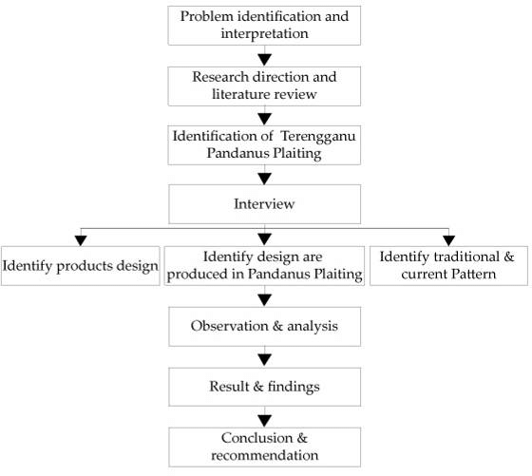
Figure 2.1: This is a sample diagram

UI Design

Overall Project Plan
Chapter 3

Implementation and Results

Every chapter should start with 1-2 sentences on the outline of the chapter.

Implementation

Performance Analysis

Results and Discussion
Chapter 4

Engineering Standards and Mapping

Every chapter should start with 1-2 sentences on the outline of the chapter.

Impact on Society, Environment and Sustainability

Impact on Life

Impact on Society & Environment

Ethical Aspects

Sustainability Plan

Project Management and Team Work
Provide a cost analysis in terms of budget required and revenue model. In case of budget, you must show an alternate budget and rationales.

Complex Engineering Problem

Mapping of Program Outcome
In this section, provide a mapping of the problem and provided solution with targeted Program Outcomes (PO’s).
Table 4.1: Justification of Program Outcomes
PO’s | Justification
PO1 | CO1 covers PO1 by teaching students fundamental programming concepts in C/C++, focusing on problem-solving techniques and manipulation, ensuring they have the core skills for understanding and applying programming principles.
PO2 | CO2 covers PO2, requiring students to analyze complex programming problems, select appropriate language constructs, and data structures for application development, aligning with advanced programming skills and problem-solving techniques.
PO9 | CO3 covers PO9, CO3 is mapped to PO9 because working in teams to design and implement a software project requires students to demonstrate effective teamwork, communication, and coordination skills. This aligns directly with PO9, which emphasizes the ability to function effectively within teams.
PO10 | CO4 covers PO10 by emphasizing the effective communication of complex engineering concepts through various mediums, including reports, presentations, and instructional materials.

Complex Problem Solving
- CO1 is linked to EP1 as students need to understand and apply basic programming concepts, requiring in-depth engineering knowledge. EP2 is relevant as students may need to balance different problem solving techniques, even at an introductory level, involving conflicting requirements. CO1 also involves EP3 since students must analyze problems thoroughly to implement effective solutions.
- CO2 is linked to EP1 because analyzing competitive programming problems and choosing the appropriate constructs requires a deep understanding of programming concepts. EP2 is also relevant, as designing, building, and testing realistic applications often involves balancing conflicting requirements. EP3 applies here too, as students need to deeply analyze each problem to select the best approach.
Table 4.2: Mapping with complex problem solving.
EP1  Depth of Knowledge | EP2  Range of Conflicting Requirements | EP3  Depth of Analysis | EP4  Familiarity of Issues | EP5  Extent of Applicable Codes | EP6  Extent Of Stakeholder Involvement | EP7  Inter- dependence
✔ | ✔

Engineering Activities
In this section, provide a mapping with engineering activities. For each mapping add subsections to put rationale (Use Table 4.3).

EA1  Range of resources | EA2  Level of Interaction | EA3  Innovation | EA4  Consequences for society and environment | EA5  Familiarity
✔ | ✔ | ✔

Chapter 5

Conclusion

Every chapter should start with 1-2 sentences on the outline of the chapter.

Summary

Limitation

Future Work

References

[1] Jon Kleinberg and Eva Tardos. Algorithm design. Pearson Education India, 2006.

